Mockito Hands-On Exercises

Exercise 1: Mocking and Stubbing:

1. ExternalApi.java code:

public interface ExternalApi {

String getData();

}

1. MyService.java code:

public class MyService {

private final ExternalApi api;

public MyService(ExternalApi api) {

this.api = api;

}

public String fetchData() {

return api.getData();

}

}

1. MyServiceTest.java code:

import org.junit.jupiter.api.Test;

import static org.junit.jupiter.api.Assertions.\*;

import static org.mockito.Mockito.\*;

public class MyServiceTest {

@Test

public void testExternalApi() {

ExternalApi mockApi = mock(ExternalApi.class);

when(mockApi.getData()).thenReturn("Mock Data");

MyService service = new MyService(mockApi);

String result = service.fetchData();

assertEquals("Mock Data", result);

}

}

Output:

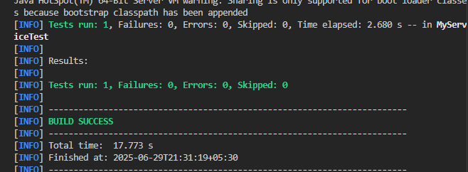

Exercise 2: Verifying Interactions:

Code:

1. and 2 same as previous exercise:

3)MyServiceTest.java code:

import org.junit.jupiter.api.Test;

import static org.junit.jupiter.api.Assertions.\*;

import static org.mockito.Mockito.\*;

public class MyServiceTest {

@Test

public void testVerifyInteraction() {

ExternalApi mockApi = mock(ExternalApi.class);

when(mockApi.getData()).thenReturn("Mock Data");

MyService service = new MyService(mockApi);

String result = service.fetchData();

assertEquals("Mock Data", result);

verify(mockApi).getData();

}

}

Output:

